**TYPES OF FOREST**

1. **TROPICAL EVERGREEN FOREST**

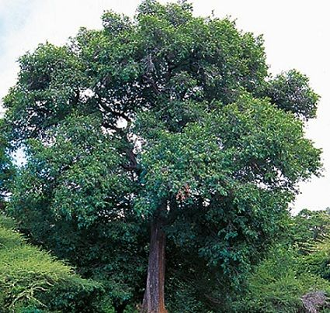 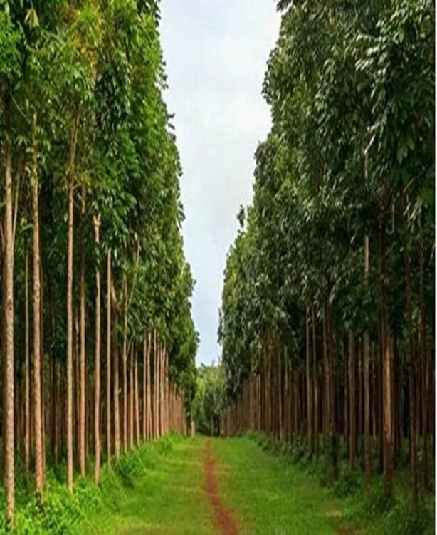

**EBONY MAHAGONY**

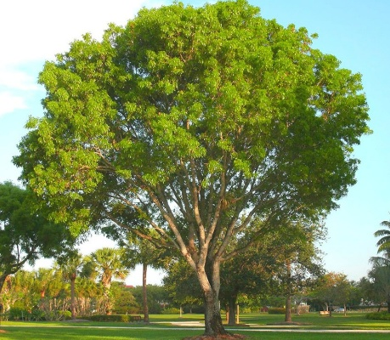 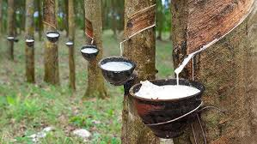

**ROSEWOOD RUBBER**

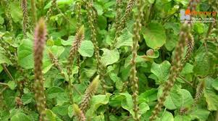

**CHIRCHONA**

1. **MONSOON FOREST OR TROPICAL DECIDUOS FOREST**

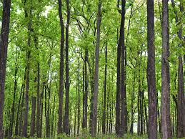 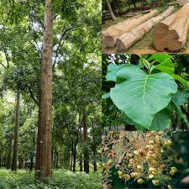

**SAL TEEK**

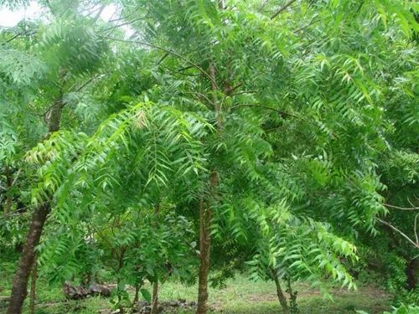 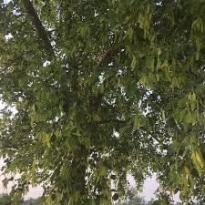

**NEEM SHISHAM**

1. **THORN FOREST OR SCRUB**

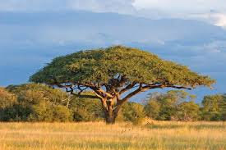 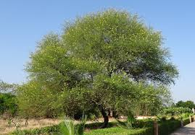

**AACIA BABOOL**

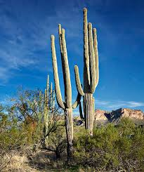 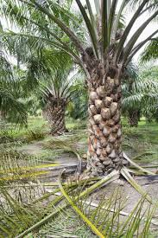

**CACTUS PALM**

1. **MONTANE FOREST**

**HEIGHT- 1000-2000**

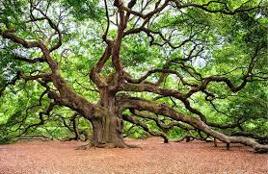 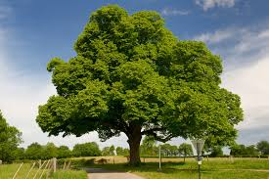

**OAKS CHESTNUT**

**HEIGHT 1500-3500(CHRISTMAS TREE FOREST)**

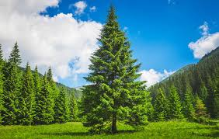 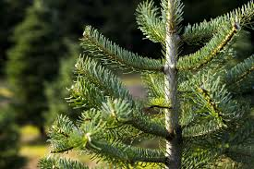

**PINE FIR**

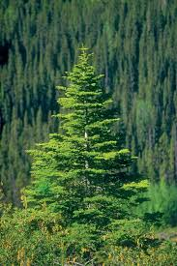 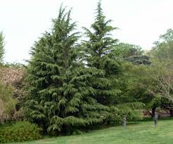

**SPRUE DEODAR**

**HEIGHT 3500 AND ABOVE**

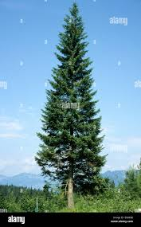 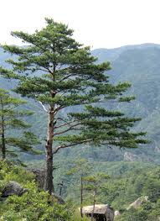

**SLIVER FIR PINE**

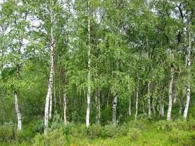

**BIRCH**

1. **MANGROVE FOREST**

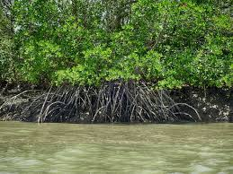 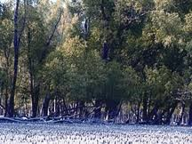

**SUNDARI TREES OF SUNDARBANS DELTA KEORA AGAR**

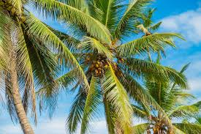 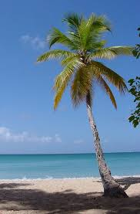

**COCONUT PALM**